**Report on Wolverhampton Blitz (05/12/22)**

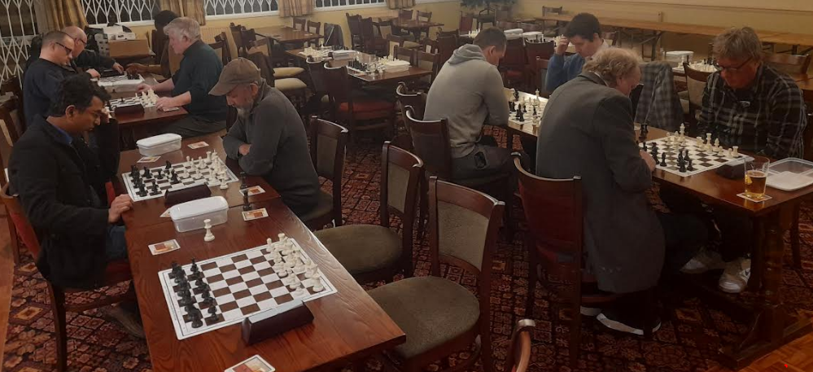

On Monday Wolverhampton hosted the first blitz night at our alternative venue. 12 Players travelled on a cold night from across the county and beyond to merge on our small club. All players started with different time controls with the stronger players on only 3 minutes whilst the lower graded players had as many as 7 minutes. With no increment this helped level the field with many top players often playing under extended time pressure. Inevitably this higher tempo chess produced some very exciting games as players blundered away their winning positions or snatched victory from the jaws of defeat.

The tournament remained close throughout with the leaders switching places numerous times throughout the evening but at the end of the night it was Bruce Baer (Mutual Circle) who triumphed scoring 5.5/7. Phil Bull (Wolverhampton) and Chris Lewis (Wolverhampton) tied for 2nd place with 5.  
  
It was a great evening and Wolverhampton are looking forward to welcoming our fellow clubs to additional blitz nights in the new year.

|  |  |  |  |  |  |  |
| --- | --- | --- | --- | --- | --- | --- |
|  | **Grade** | **P** | **W** | **D** | **L** | **Pts** |
| Bruce Baer | 1957 | 7 | 5 | 1 | 1 | 5.5 |
| Phil Bull | 1740 | 7 | 5 | 0 | 2 | 5 |
| Chris Lewis | 1861 | 7 | 5 | 0 | 2 | 5 |
| Matthew Harborne | 2070 | 7 | 4 | 1 | 2 | 4.5 |
| Andrew Adams | 1479 | 7 | 4 | 1 | 2 | 4.5 |
| Tony Preece | 1852 | 7 | 4 | 0 | 3 | 4 |
| Rajeev Raghavan | 1776 | 7 | 4 | 0 | 3 | 4 |
| Shahab Quraishi | 1855 | 7 | 3 | 1 | 3 | 3.5 |
| Nicholas Walker | 1959 | 7 | 3 | 0 | 4 | 3 |
| Oluwole Ogeleye | 1825 | 7 | 2 | 0 | 5 | 2 |
| Peter Jones | 1697 | 7 | 1 | 0 | 6 | 1 |
| John Lee | 1639 | 7 | 0 | 0 | 7 | 0 |

**1st** Bruce Baer **2nd= & U1830 Grading Prize** Phil Bull **2nd= & U1900 Grading Prize** Chris Lewis **U1700 Grading Prize** Andrew Adams

|  |  |  |
| --- | --- | --- |
| **Round 1** |  |  |
| Oluwole Ogeleye | 0-1 | Matthew Harborne |
| Nicholas Walker | 0-1 | Rajeev Raghavan |
| Phil Bull | 0-1 | Bruce Baer |
| Chris Lewis | 1-0 | Peter Jones |
| John Lee | 0-1 | Shahab Quraishi |
| Tony Preece | 0-1 | Andrew Adams |

|  |  |  |
| --- | --- | --- |
| **Round 2** |  |  |
| Matthew Harborne | 0.5-0.5 | Shahab Quraishi |
| Bruce Baer | 1-0 | Rajeev Raghavan |
| Andrew Adams | 0-1 | Chris Lewis |
| Phil Bull | 1-0 | Nicholas Walker |
| Peter Jones | 0-1 | Tony Preece |
| John Lee | 0-1 | Oluwole Ogeleye |

|  |  |  |
| --- | --- | --- |
| **Round 3** |  |  |
| Chris Lewis | 0-1 | Bruce Baer |
| Tony Preece | 0-1 | Matthew Harborne |
| Shahab Quraishi | 1-0 | Phil Bull |
| Oluwole Ogeleye | 0-1 | Andrew Adams |
| Rajeev Raghavan | 1-0 | Peter Jones |
| Nicholas Walker | 1-0 | John Lee |
| **Round 4** |  |  |
| Bruce Baer | 0-1 | Matthew Harborne |
| Shahab Quraishi | 0-1 | Chris Lewis |
| Andrew Adams | 1-0 | Rajeev Raghavan |
| Oluwole Ogeleye | 0-1 | Nicholas Walker |
| Phil Bull | 1-0 | Tony Preece |
| Peter Jones | 1-0 | John Lee |

|  |  |  |
| --- | --- | --- |
| **Round 5** |  |  |
| Matthew Harborne | 0-1 | Chris Lewis |
| Andrew Adams | 0.5-0.5 | Bruce Baer |
| Tony Preece | 1-0 | Shahab Quraishi |
| Nicholas Walker | 1-0 | Peter Jones |
| Rajeev Raghavan | 1-0 | Oluwole Ogeleye |
| John Lee | 0-1 | Phil Bull |

|  |  |  |
| --- | --- | --- |
| **Round 6** |  |  |
| Chris Lewis | 0-1 | Phil Bull |
| Matthew Harborne | 1-0 | Andrew Adams |
| Bruce Baer | 1-0 | Nicholas Walker |
| Shahab Quraishi | 1-0 | Rajeev Raghavan |
| John Lee | 0-1 | Tony Preece |
| Peter Jones | 0-1 | Oluwole Ogeleye |

|  |  |  |
| --- | --- | --- |
| **Round 7** |  |  |
| Phil Bull | 1-0 | Matthew Harborne |
| Bruce Baer | 1-0 | Shahab Quraishi |
| Oluwole Ogeleye | 0-1 | Chris Lewis |
| Andrew Adams | 1-0 | Peter Jones |
| Nicholas Walker | 0-1 | Tony Preece |
| Rajeev Raghavan | 1-0 | John Lee |

Report by: Christopher Lewis